Position – Time Graphs

The slope of a position-time graph represents velocity.

The steeper the slope is, the faster the motion is changing. Average velocity can be calculated from a position-time graph as the change in position divided by the corresponding change in time. 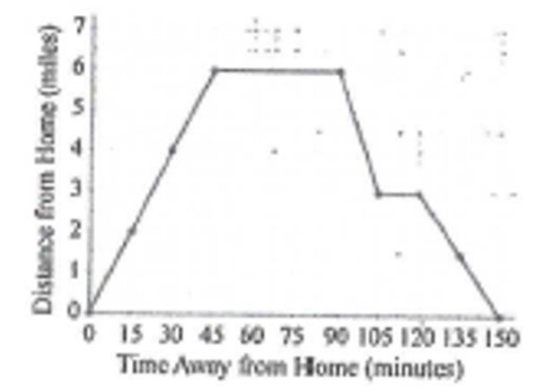

Ted bicycled 6 miles from his house to the mall, then returned home.

- How long was he at the mall?
- How long was Ted actually riding his bike?
- What was his average rate going to the mall?

